

CO-1 ASSESSMENT-2
DSA0406-Data Handling and visualization

Submitted by,
Sai Hasnika.R
192424178

Question 1: Mapping Data onto Aesthetics

CODING:
library(ggplot2)
# Dataset
product <- data.frame(
Product=c("P1","P2","P3","P4","P5","P6"),
Sales=c(120,90,150,80,135,100),
Profit=c(18,12,25,8,22,16),
Category=c("Electronics","Clothing","Electronics","Furniture","Furniture","Clothing")
)
# Scatter Plot
ggplot(product, aes(x=Sales,
y=Profit,
color=Category,
size=Sales))+
geom_point(alpha=0.9)+
geom_text(aes(label=Product),
vjust=-1,
size=5,
color="black")+
scale_color_manual(values=c("Electronics"="#FF6B6B",
"Clothing"="#4ECDC4",
"Furniture"="#FFD93D"))+
scale_size(range=c(5,15))+
labs(title="Sales vs Profit by Category",
x="Sales (₹ Lakhs)",
y="Profit (%)")+
theme_minimal(base_size=15)
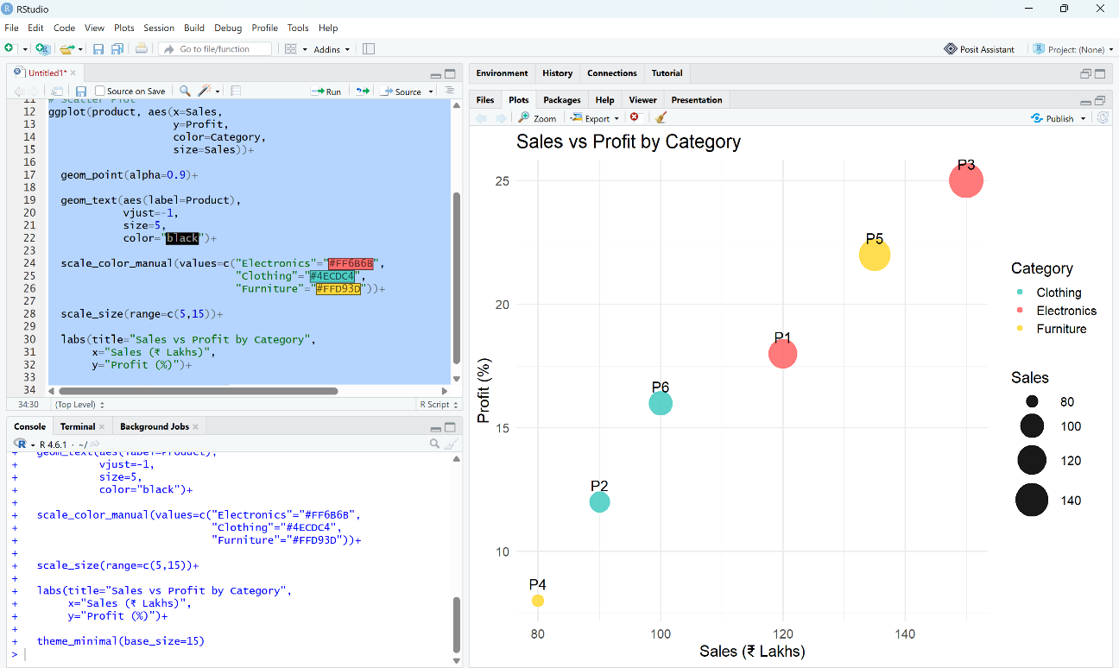

Question 2: Coordinate Systems
CODING:

library(ggplot2)
direction<-data.frame(
Direction=c("N","NE","E","SE","S","SW","W","NW"),
Frequency=c(18,12,20,15,22,11,16,14)
)
# Cartesian Bar Chart
ggplot(direction,
aes(Direction,
Frequency,
fill=Frequency))+
geom_col(width=0.7)+
scale_fill_gradient(low="#00B4D8",
high="#03045E")+
labs(title="Wind Direction Frequency")+
theme_minimal(base_size=15)

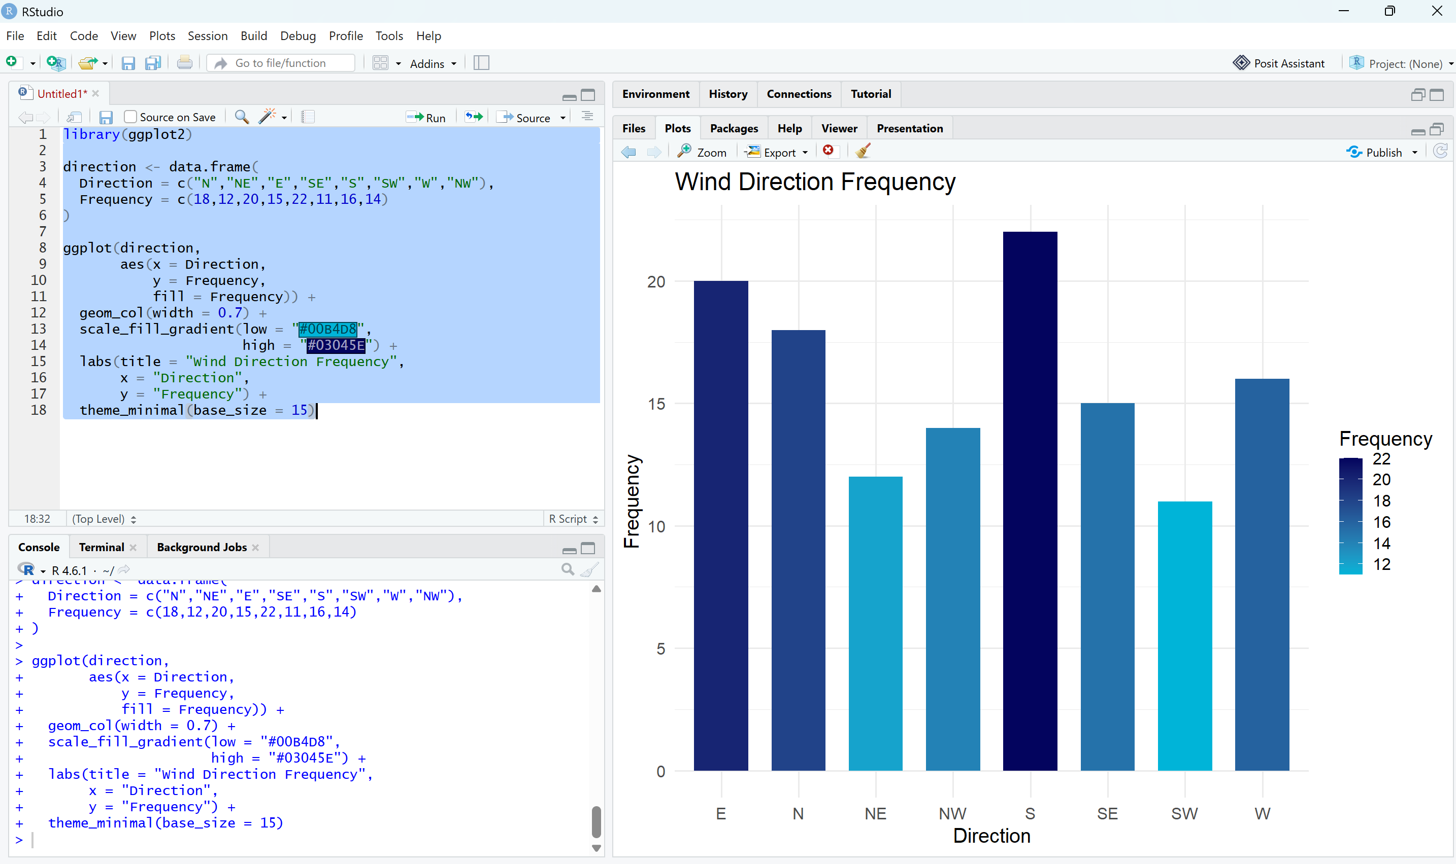
Polar Chart

ggplot(direction,
aes(x="",
y=Frequency,
fill=Direction))+
geom_col(color="white")+

coord_polar(theta="y")+
scale_fill_brewer(palette="Set3")+

labs(title="Directional Frequency (Polar)")+
theme_void(base_size=15)

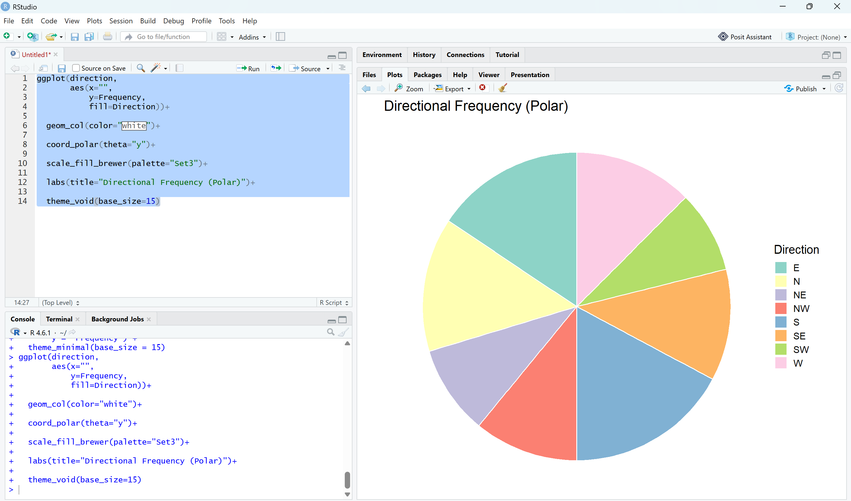
Question 3: Color Scales

CODING:

library(ggplot2)
student<-data.frame(
Student=c("A","B","C","D","E","F"),
Marks=c(45,58,72,81,67,90)
)
ggplot(student,
aes(Student,
Marks,
fill=Marks))+
geom_col(width=0.7)+
scale_fill_gradient(low="#90E0EF",
high="#0077B6")+
geom_text(aes(label=Marks),
vjust=-0.6,
size=5)+
labs(title="Student Marks",
x="Student",
y="Marks")+
theme_minimal(base_size=15)

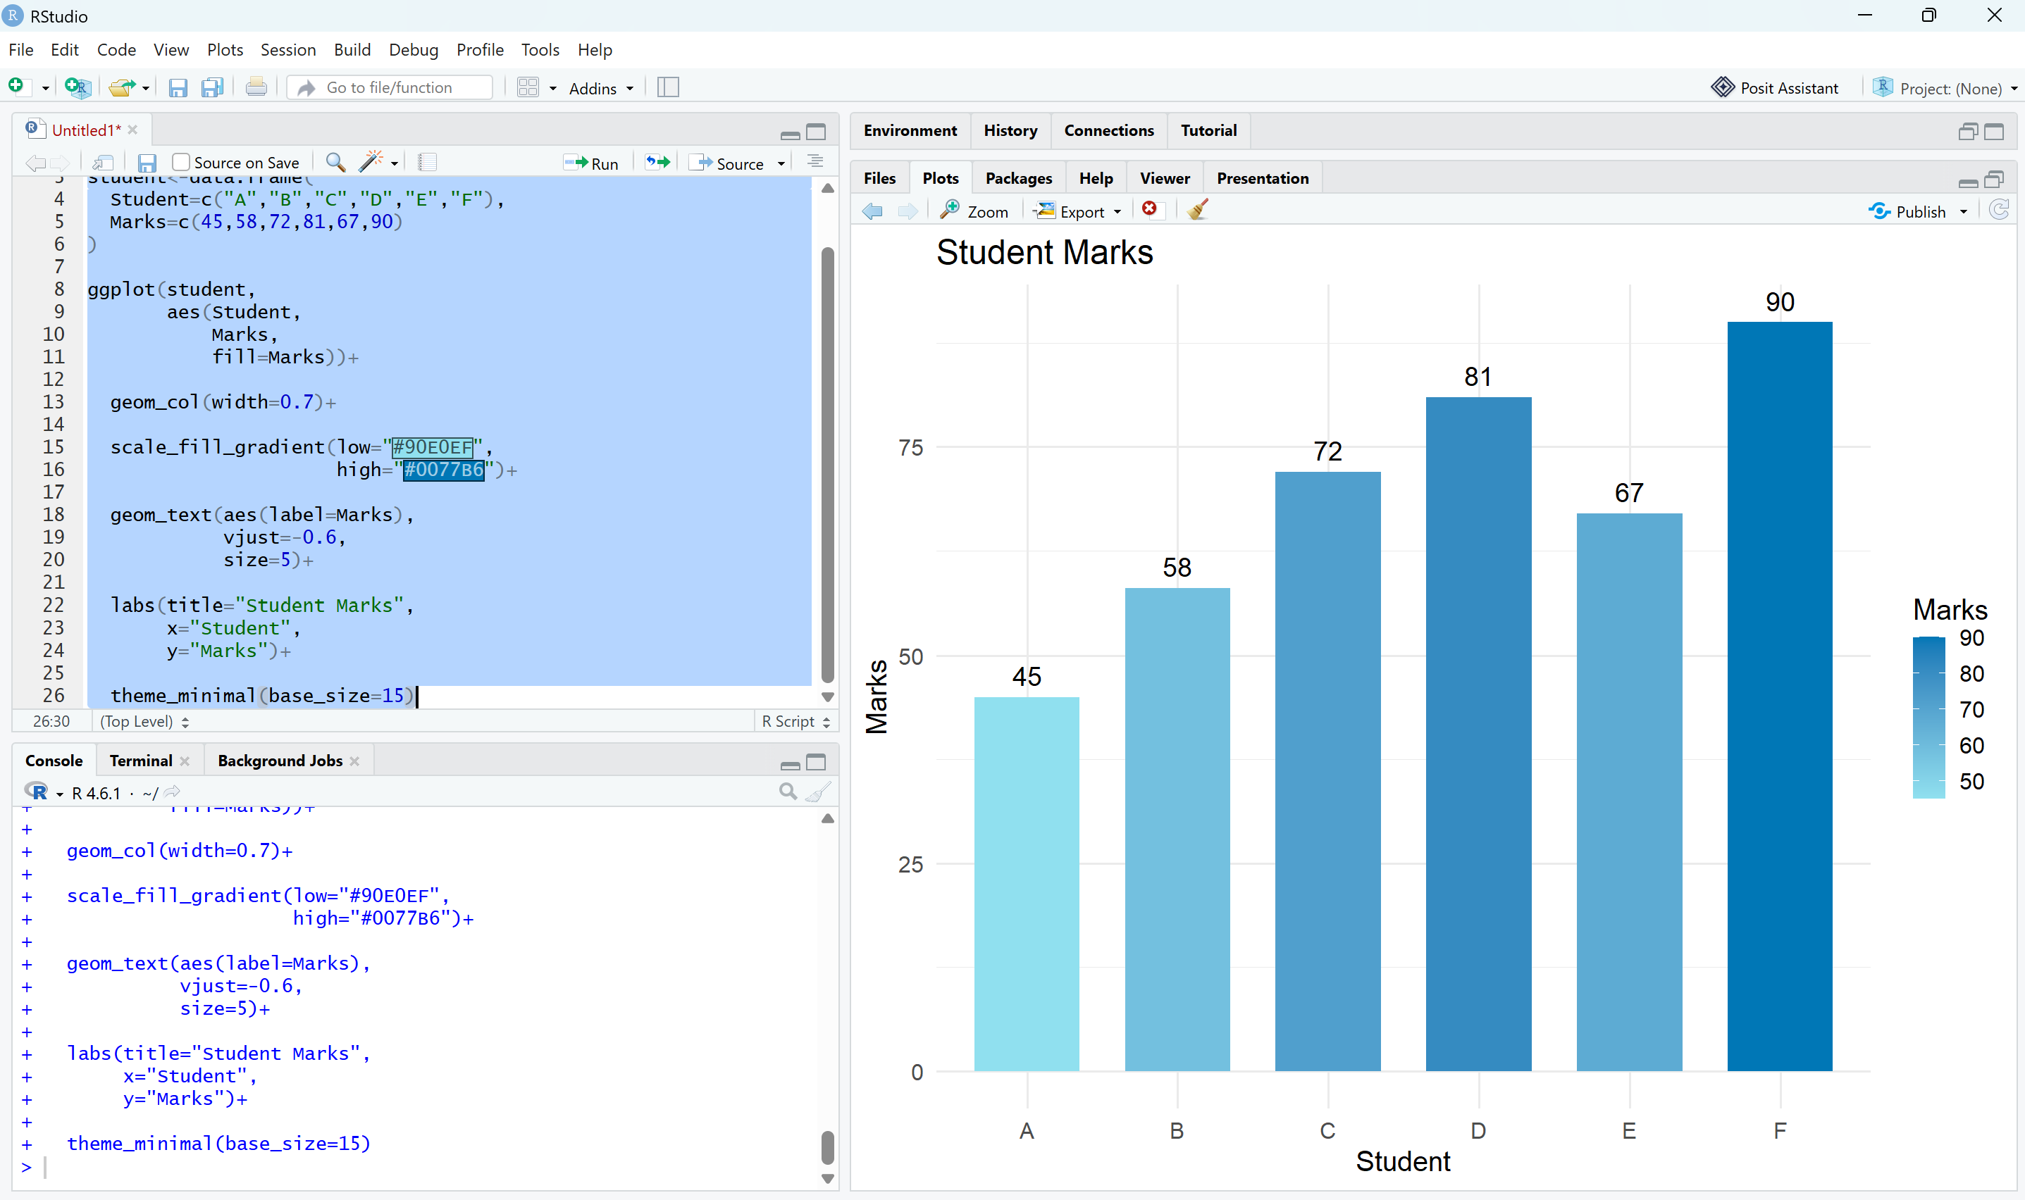
Question 4: Highlighting with Color

CODING:

library(ggplot2)
revenue<-data.frame(
Region=c("North","South","East","West","Central"),
Revenue=c(820,760,790,1010,770)
)
revenue$Color<-ifelse(revenue$Revenue==max(revenue$Revenue),
"Highest",
"Others")
ggplot(revenue,
aes(Region,
Revenue,
fill=Color))+
geom_col(width=0.7)+
scale_fill_manual(values=c("Highest"="#E63946",
"Others"="#A8DADC"))+
geom_text(aes(label=Revenue),
vjust=-0.5,
size=5)+
labs(title="Regional Revenue Comparison")+

theme_minimal(base_size=15)
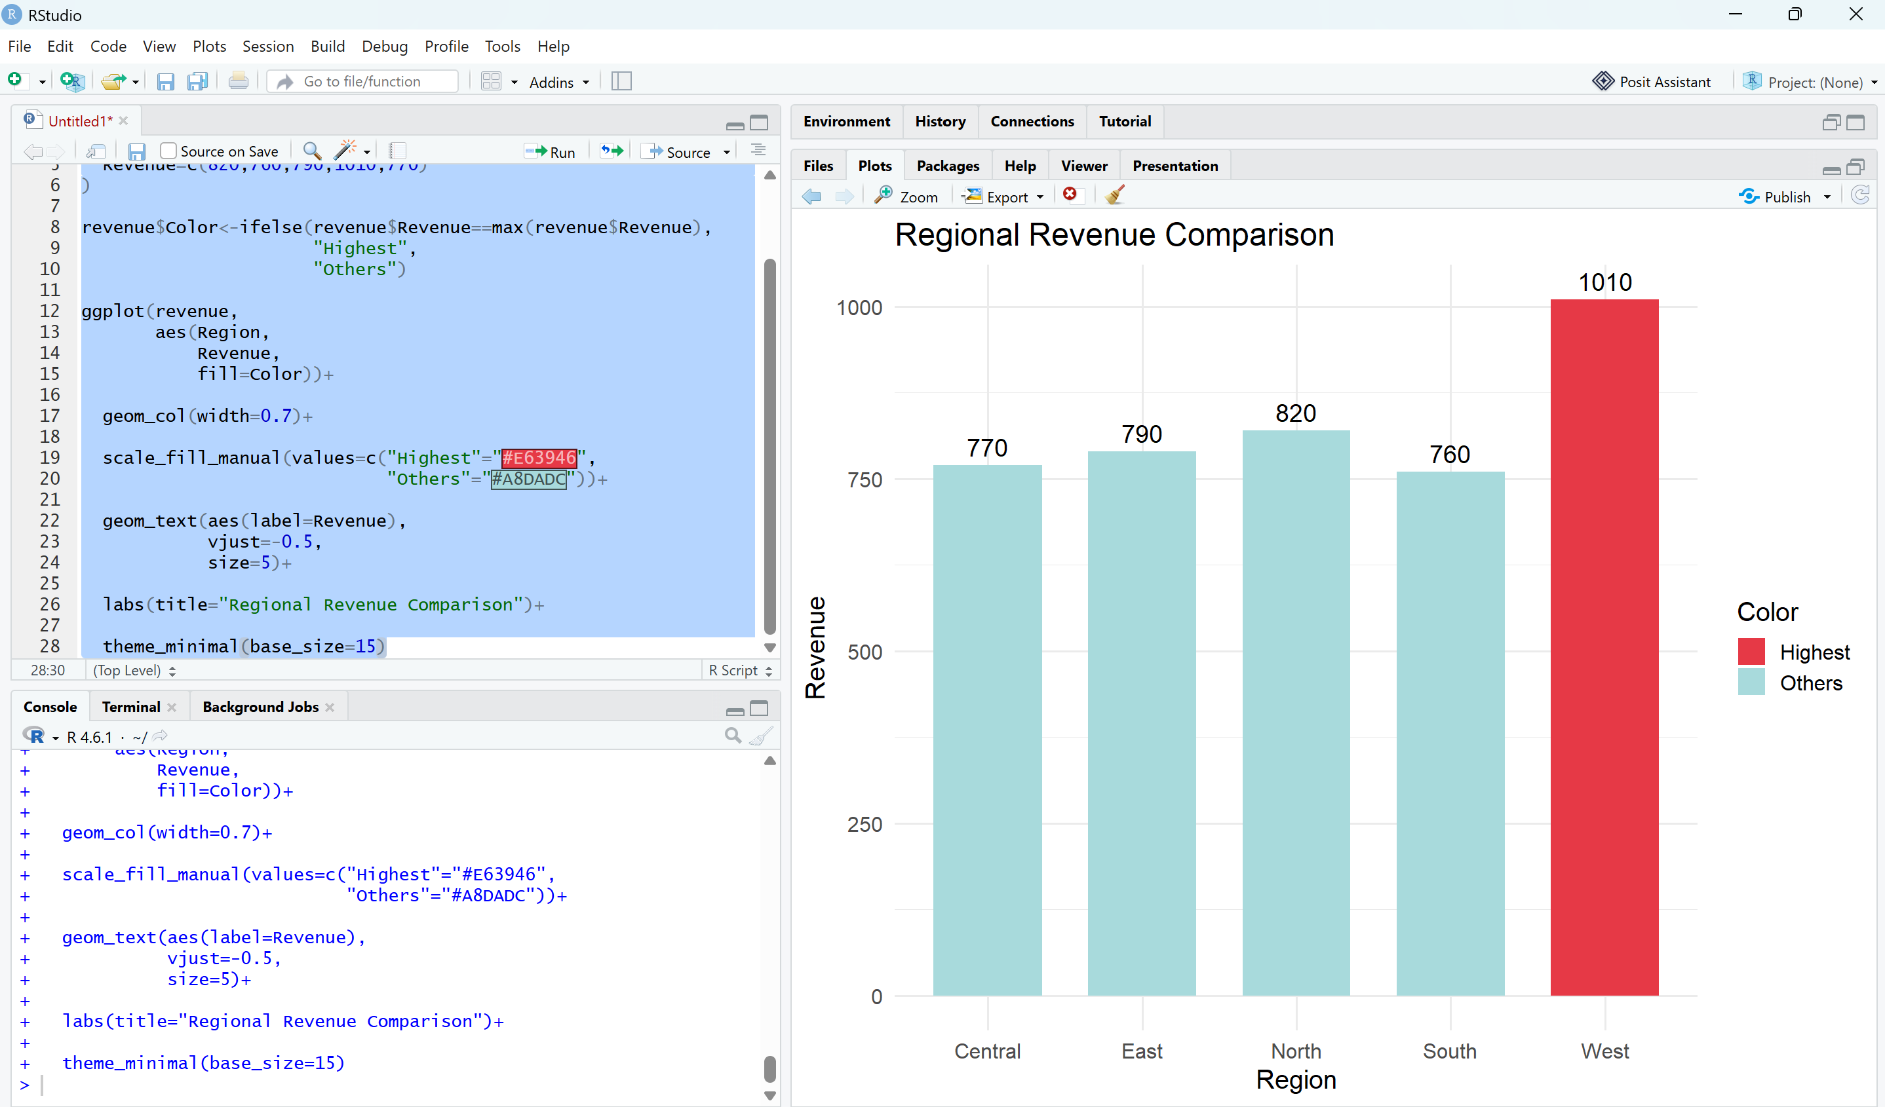
Question 5: Integrated Visualization

CODING:

library(ggplot2)
city<-data.frame(
City=c("A","B","C","D","E"),
Population=c(8.2,5.6,9.4,6.8,4.9),
AQI=c(110,180,90,240,150),
Rainfall=c(850,430,1200,520,680),
Region=c("North","South","North","East","West")
)
ggplot(city,
aes(x=Population,
y=AQI,
size=Rainfall,
color=Region))+
geom_point(alpha=0.8)+
geom_text(aes(label=City),
vjust=-1,
size=5,
color="black")+
scale_color_manual(values=c(
North="#4361EE",
South="#F72585",
East="#06D6A0",
West="#F4A261"
))+
scale_size(range=c(6,20))+

labs(title="City Population vs AQI",
x="Population (Million)",
y="AQI")+
theme_minimal(base_size=15)

